**Add a vote row (using HTTP POST) to the vote table, for a specific artist**

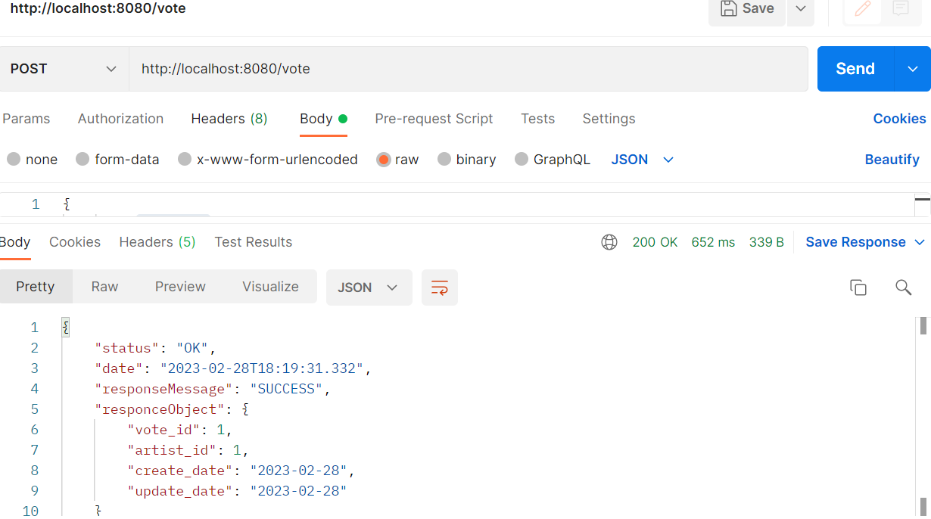

API : http://localhost:8080/vote

Request :

{        "artist_id": 1

}

Response:

{

    "status": "OK",

    "date": "2023-02-28T18:27:07.546",

    "responseMessage": "SUCCESS",

    "responceObject": {

        "vote_id": 1,

        "artist_id": 1,

        "create_date": "2023-02-28",

        "update_date": "2023-02-28"

    }

}

**Get an overview/data summary. All artists, with vote count for each**

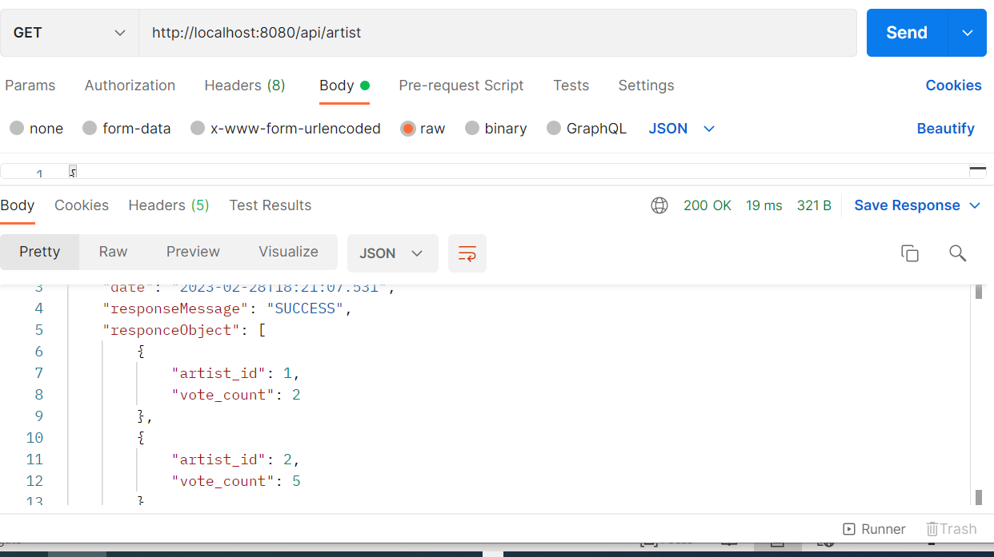

API: http://localhost:8080/api/artist

Response :

{

    "status": "OK",

    "date": "2023-02-28T18:27:56.263",

    "responseMessage": "SUCCESS",

    "responceObject": [

        {

            "artist_id": 1,

            "vote_count": 2

        },

        {

            "artist_id": 2,

            "vote_count": 5

        }

    ]

}

**Get a data summary for a specific artist, with vote count for that artist only.**

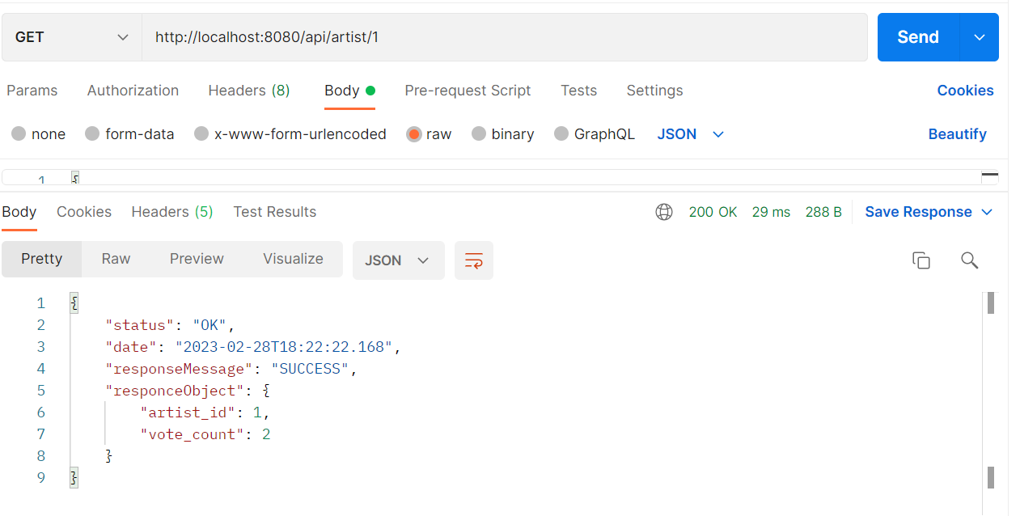

API : http://localhost:8080/api/artist/1

Response:

{

    "status": "OK",

    "date": "2023-02-28T18:28:50.035",

    "responseMessage": "SUCCESS",

    "responceObject": {

        "artist_id": 1,

        "vote_count": 2

    }

}

**All responses are in JSON, with a success message and the date Time of the operation**

{

    "status": "OK",

    "date": "2023-02-28T18:31:01.159",

    "responseMessage": "SUCCESS",

    "responceObject": {

        "artist_id": 2,

        "vote_count": 5

    }

}

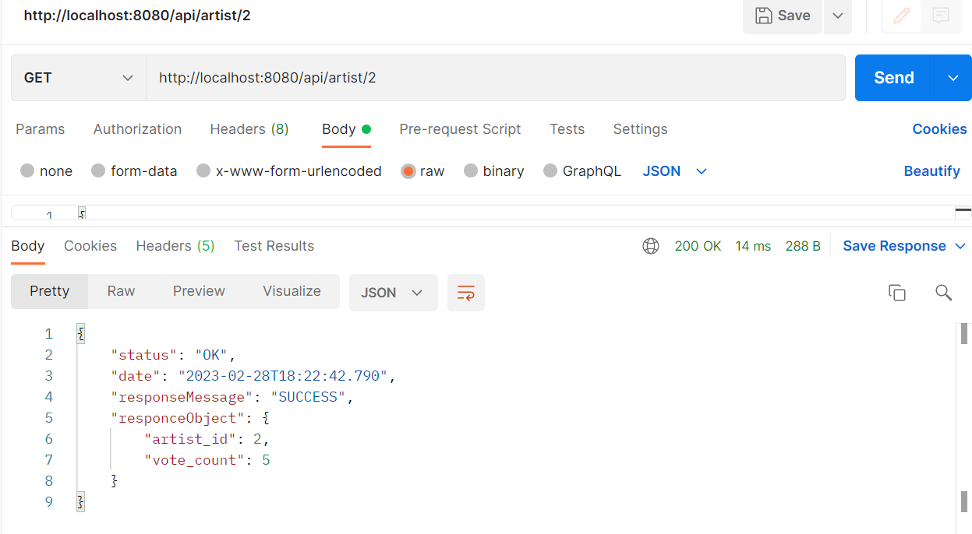

API : http://localhost:8080/api/artist/2

Response :

{

    "status": "OK",

    "date": "2023-02-28T18:29:24.707",

    "responseMessage": "SUCCESS",

    "responceObject": {

        "artist_id": 2,

        "vote_count": 5

    }

}